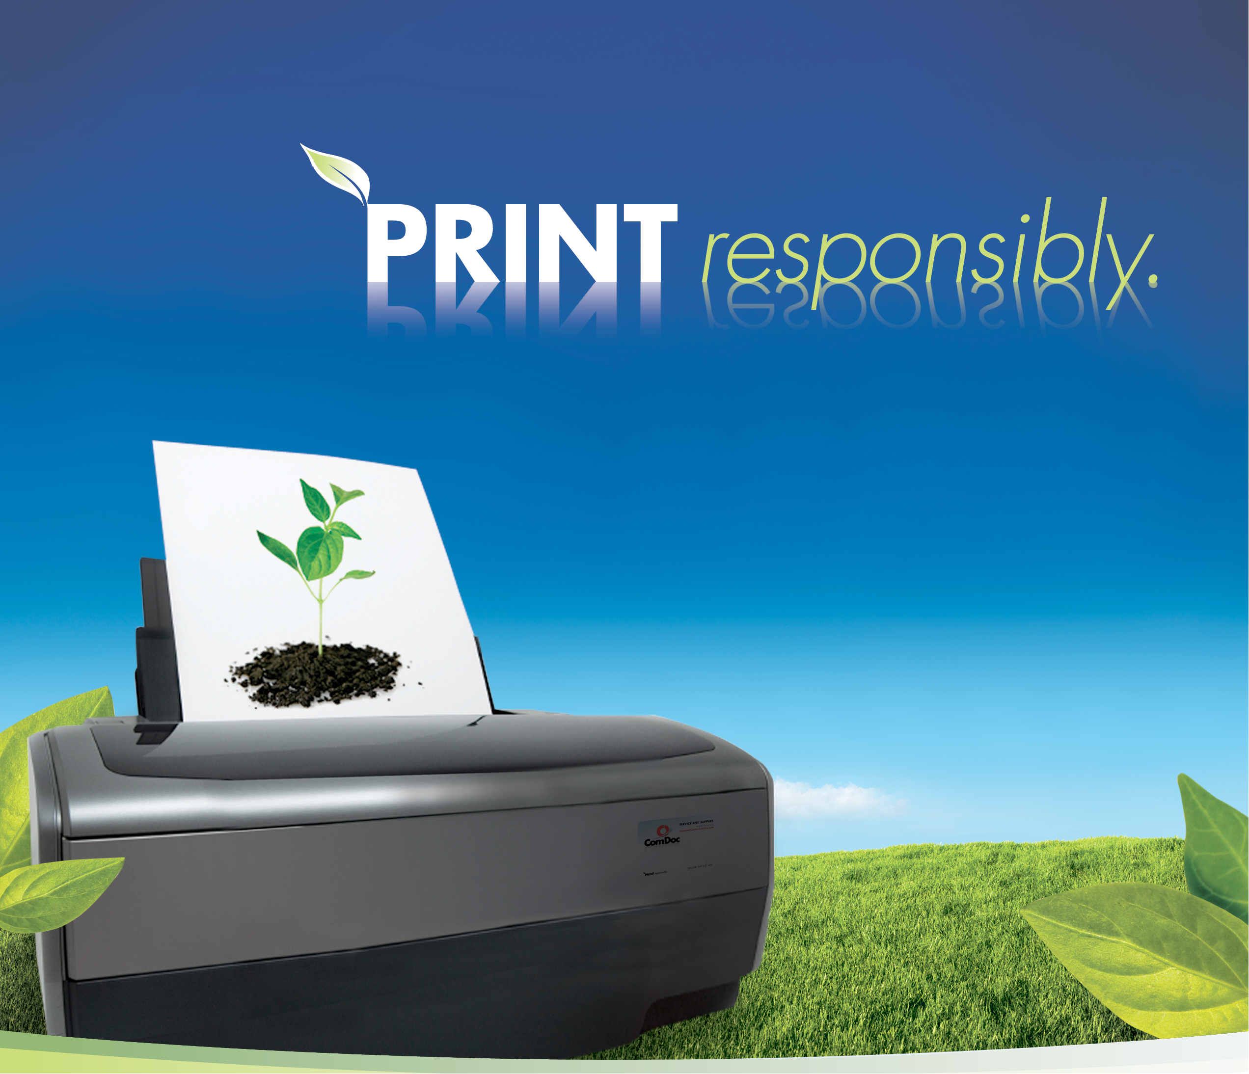
Plum Area School District

July 2017

Noah Stoczynski
Enterprise Account Manager
ComDoc
Office: (412) 505-9758
nstoczynski@comdoc.com

Executive Summary

July 2017

John Zahorchak
Plum Area School District
900 Elicker Road
Pittsburgh, PA 15239

Dear John,

We appreciate the opportunity to expand our relationship with Plum Area School District. From our meetings, account reviews, and discussions I have learned that you would like to the following for the district:

- Improve the district’s ability to effectively produce documentation
- Provide a solution for the district accounting for the district’s copy center employee
- Open to leasing equipment to assist with monthly expenses involved in printing
- Consider different options with the recommendation
- Provide the district with additional new equipment
- Understanding that 1,018,356 impressions are ran each month in the copy center
- Ensure a smooth transition from a copy center the transition to a decentralized document solutions strategy
- Leave the current equipment at Regency as the school will be open one more year
- Provide systems that will increase the speed and workload that the teachers and administrators will utilize the equipment for
- Rightsizing volume for copiers and printers
- Include a solution that will mirror the current solution from a service and supply perspective on both the copiers and printers
- Provide a cost savings to the district

Thank you again for the opportunity to expand our business. If you have any questions please let me know and I look forward to hearing from you.
Sincerely,

Noah Stoczynski
Enterprise Account Manager

Current Situation

72 month lease agreement for hardware: $7,853.00
- (7) 85 ppm bw systems
- (4) 75 ppm bw systems
- (3) 62 ppm bw systems
- (1) 65 ppm bw system
- (5) 35 ppm bw systems
- (1) 30 ppm bw system
- (1) Sharp 41 ppm color system
- (1) Xerox 35 ppm color system
- (3) 110 ppm systems in copy center
- (3) Fiery front end controllers

Copier Maintenance Agreement: $7,243.00
- Allowance of 17,808,000 bw impressions @ $.0048
- Allowance of 6,000 color impressions @ $.046
- Annual reconciliation
- BW actual volume: 19,100, 734 impressions
- Color actual volume: 49,307 impressions

Copier Overage expenses:
- BW: 19,100,734 – 17,808,000 = 1,292,734 @ $.0048
$6,205.12 / 12 $517.09
- Color : 49,307 – 6,000 = 43,307 @ $.046
$1,992.12 / 12 $166.01

Printer Maintenance Agreement: $564.00
- BW Allowance of 564,000 impressions @ $.012
- BW actual volume: 331,647 impressions

Copy Center Employee: $3,500
- $42,000 annual salary to include benefits

Total monthly expense $19,843.10

ComDoc Recommendation

Xerox C8045
- Digital copy, print, scan, and fax
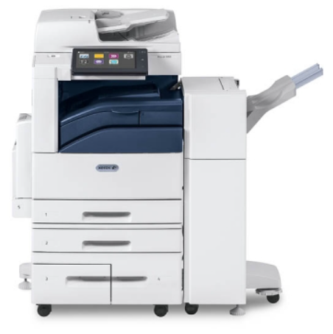
- 130 sheet single pass document feeder
- 45 pages per minute black and white
- 45 pages per minute color
- Color Touch Screen
- 1200 x 2400 dpi
- Scan to email and folder
- Color Scanning
- 4,700 total sheet standard paper supply
(2) 500 sheet paper trays
(1) 2,000 sheet paper tray
(1) 1,600 sheet paper tray
(1) 100 sheet bypass tray
- Automatic reduce and enlarge
- 11”x17” capability
- Finisher (stapling)
- Hole Punch
- Postscript

Xerox B8045
- Digital copy, print, scan, and fax
- 130 sheet single pass document feeder
- 45 pages per minute black and white
- Color Touch Screen
- 1200 x 2400 dpi
- Scan to email and folder
- Color Scanning
- 4,700 total sheet standard paper supply
(2) 500 sheet paper trays
(1) 2,000 sheet paper tray
(1) 1,600 sheet paper tray
(1) 100 sheet bypass tray
- Automatic reduce and enlarge
- 11”x17” capability
- Finisher (stapling)
- Hole Punch
- Postscript

Xerox B7035
- Digital copy, print, scan, and fax
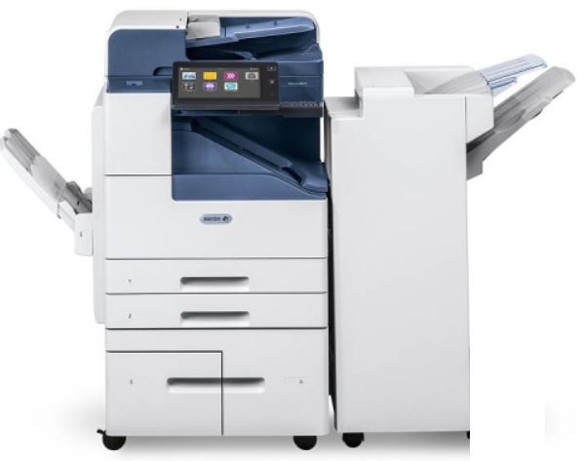
- 110 sheet reversing document feeder
- 35 pages per minute black and white
- Color Touch Screen
- 600 x 600 dpi
- Scan to email and folder
- Color Scanning
- 4,700 total sheet standard paper supply
(2) 500 sheet paper trays
(1) 1,600 sheet paper tray
(1) 2,000 sheet paper tray
(1) 100 sheet bypass tray
- Automatic reduce and enlarge
- 11”x17” capability
- Finisher and hole punch
- Postscript

Xerox D95 production unit
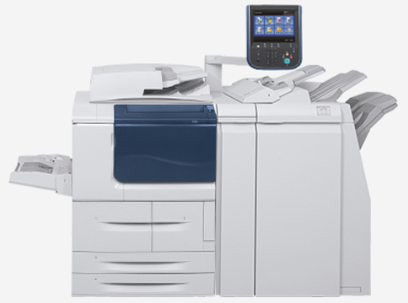
- Digital copy, print, and scan
- 250 sheet single pass document feeder
- 95 pages per minute black and white
- Color Touch Screen
- 600 x 600 dpi
- Scan to email
- Color Scanning
- 4,050 total sheet standard paper supply
(2) 550 sheet paper trays
(1) 1,100 sheet paper tray
(1) 1,600 sheet paper tray
(1) 250 sheet bypass tray
- Automatic reduce and enlarge
- 11” x 17” capability
- Finisher (stapling)
- Hole Punch

Xerox D110 copy center unit (remain in place)
- Digital copy, print, and scan
- 250 sheet single pass document feeder
- 110 pages per minute black and white
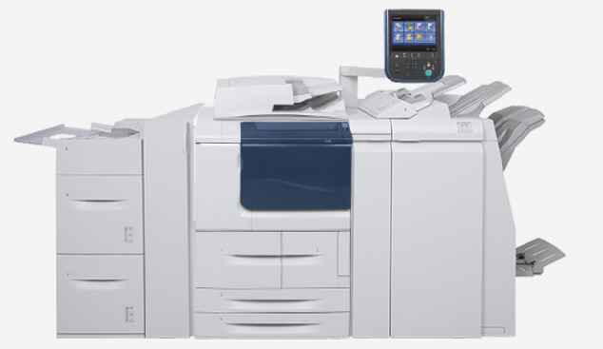
- Color Touch Screen
- 600 x 600 dpi
- Scan to email
- Color Scanning
- 8,050 total sheet paper supply
(2) 550 sheet paper trays
(1) 1,100 sheet paper tray
(1) 1,600 sheet paper tray
(2) 2,000 sheet paper trays
(1) 250 sheet bypass tray
- Automatic reduce and enlarge
- 11” x 17” capability
- Booklet Finisher (stapling)
- Hole Punch
- Fiery front end controller

ComDoc Recommendation Pricing

63 month lease agreement and 90 day deferred $18,752.00
- (17) Xerox D95s (new)
- (5) Xerox B7035s (new)
- (2) Xerox B8045 (new
- (2) Xerox C7845 (new)
- (3) Xerox D110s (remain in place)
- Annual Allowances of Volume to be shared throughout the district:
  - 19,100,734 Black and white impressions at $.0041
  - 49,307 Color impressions at $.0467
- Annual Allowance of Volume:
  - 332,000 Black and white impressions at $.012
- Hardware, Parts, Service, and Labor
- All Toner and Supplies (excluding paper and staples)
- Delivery, Installation, Connectivity, and Driver Downloads
- On-going Training
- Help Desk and Customer Center Online
- Providing a transition employee to work in the copy center at the beginning of the agreement

Benefits of Recommendation

- Assist and ease the transition between the district having a full time copy center employee
- Provide copy center level systems throughout the district. This will provide the district the proper units for the increased volume in the schools
- Adding an additional (4) D95 systems to the current fleet of equipment
- Adding an additional B8045 system in the high school front office
- Increasing the size of the machine in the Special education department to the next segment up
- Keeping the copy center in place for the beginning of the agreement
- Right size the volumes for both copiers and printers
- One provider looking out in the best interest of the district and providing options to produce the most economical way to print documents
- Providing a cost savings to the district

Year 1 Savings $66,075.90
Year 2 Savings $55,093.20
Year 3-5 Savings $165,279.60
Year 5.5 savings $27,546.00
Total agreement savings $313,994.00

*First three months of the agreement no payments are to be made, $56,256.00*

